The Middle – Pilot
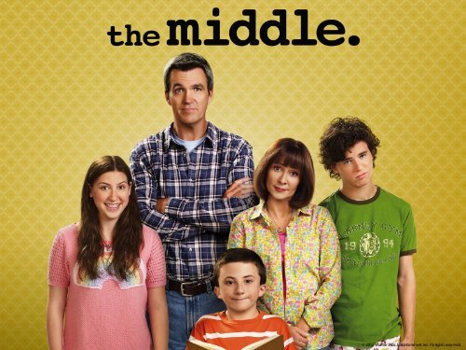
- While you are watching, write down the words that are missing in the subtitles.
1. | 6.
2. | 7.
3. | 8.
4. | 9.
5. | 10.

- After you’ve watched the episode, answer these questions about the episode.
- Translate these words:
English | Dutch | English | Dutch
Hibernate |  | Imperative
Quarry |  | Soothe
Paedophile |  | Quirky
Base salary |  | Benefit
Matchmaker |  | Dependable

- The Heck family lives in Indiana, one of America’s states.
How many states does America have?
…………………………………………………………………………………………..
What is the biggest state?
…………………………………………………………………………………………..
What is the smallest state?
…………………………………………………………………………………………..
Why is it called the ‘United States of America’? What are the ‘united’ rights and duties and what rights do the individual states have?
…………………………………………………………………………………………..
How many people live in America?
…………………………………………………………………………………………..
- What are the names of Franky’s 3 children and what is wrong with each child?
1.
2.
3.

- Franky needs to sell a car to make a commission, what does it mean to work commission-based?
…………………………………………………………………………………………..
Find 5 big American companies that use the commission-model for their employees.
1. ………………………………………………………………………………………
2. ………………………………………………………………………………………
3. ………………………………………………………………………………………
4. ………………………………………………………………………………………
5. ………………………………………………………………………………………
- Axel gets punished because he called his coach a moron. He is sent to Sue’s room. What do you think would be a good punishment for a child?
…………………………………………………………………………………………..

- Write down at least 3 things that you’ve seen in this episode which are typically American.
1. ……………………………………………………………………………………..
2. ……………………………………………………………………………………..
3. ……………………………………………………………………………………..

